COS20019

Cloud Computing Architechture

Truong Ngoc Gia Hieu

105565520

Week 6 – ACF Lab 1:

Intro to AWS IAM

**Lab 1: Introduction to AWS IAM**

**AWS Identity and Access Management (IAM)** is a web service that enables Amazon Web Services (AWS) customers to manage users and user permissions in AWS. With IAM, you can centrally manage **users, security credentials** such as access keys, and **permissions** that control which AWS resources users can access.

**A. Lab overview and objectives**

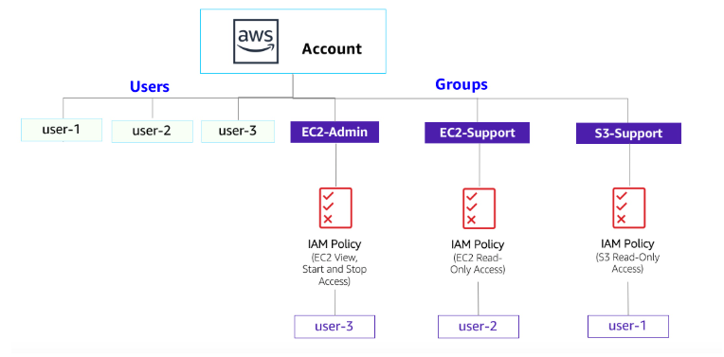This lab will demonstrate:

* Exploring pre-created **IAM Users and Groups**
* Inspecting **IAM policies** as applied to the pre-created groups
* Following a **real-world scenario**, adding users to groups with specific capabilities enabled
* Locating and using the **IAM sign-in URL**
* **Experimenting** with the effects of policies on service access

**AWS service restrictions**

In this lab environment, access to AWS services and service actions might be restricted to the ones that are needed to complete the lab instructions. You might encounter errors if you attempt to access other services or perform actions beyond the ones that are described in this lab.

**AWS Identity and Access Management**

AWS Identity and Access Management (IAM) can be used to:

* **Manage IAM Users and their access:** You can create Users and assign them individual security credentials (access keys, passwords, and multi-factor authentication devices). You can manage permissions to control which operations a User can perform.
* **Manage IAM Roles and their permissions:** An IAM Role is similar to a User, in that it is an AWS identity with permission policies that determine what the identity can and cannot do in AWS. However, instead of being uniquely associated with one person, a Role is intended to be *assumable* by anyone who needs it.
* **Manage federated users and their permissions:** You can enable *identity federation* to allow existing users in your enterprise to access the AWS Management Console, to call AWS APIs and to access resources, without the need to create an IAM User for each identity.

**Duration**

This lab takes approximately **40 minutes** to complete.

**B. Accessing the AWS Management Console**

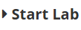

At the top of the lab, click the button to start lab and wait until the button next to the AWS turns from red to green.

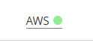

***Figure 1: AWS Management Console Activated***

**C. Task 1: Explore the Users and Groups**

**Step 1.1:** After opening the AWS Management Console, search IAM in the box which next to the service icon and select the first one.

***Figure 2: 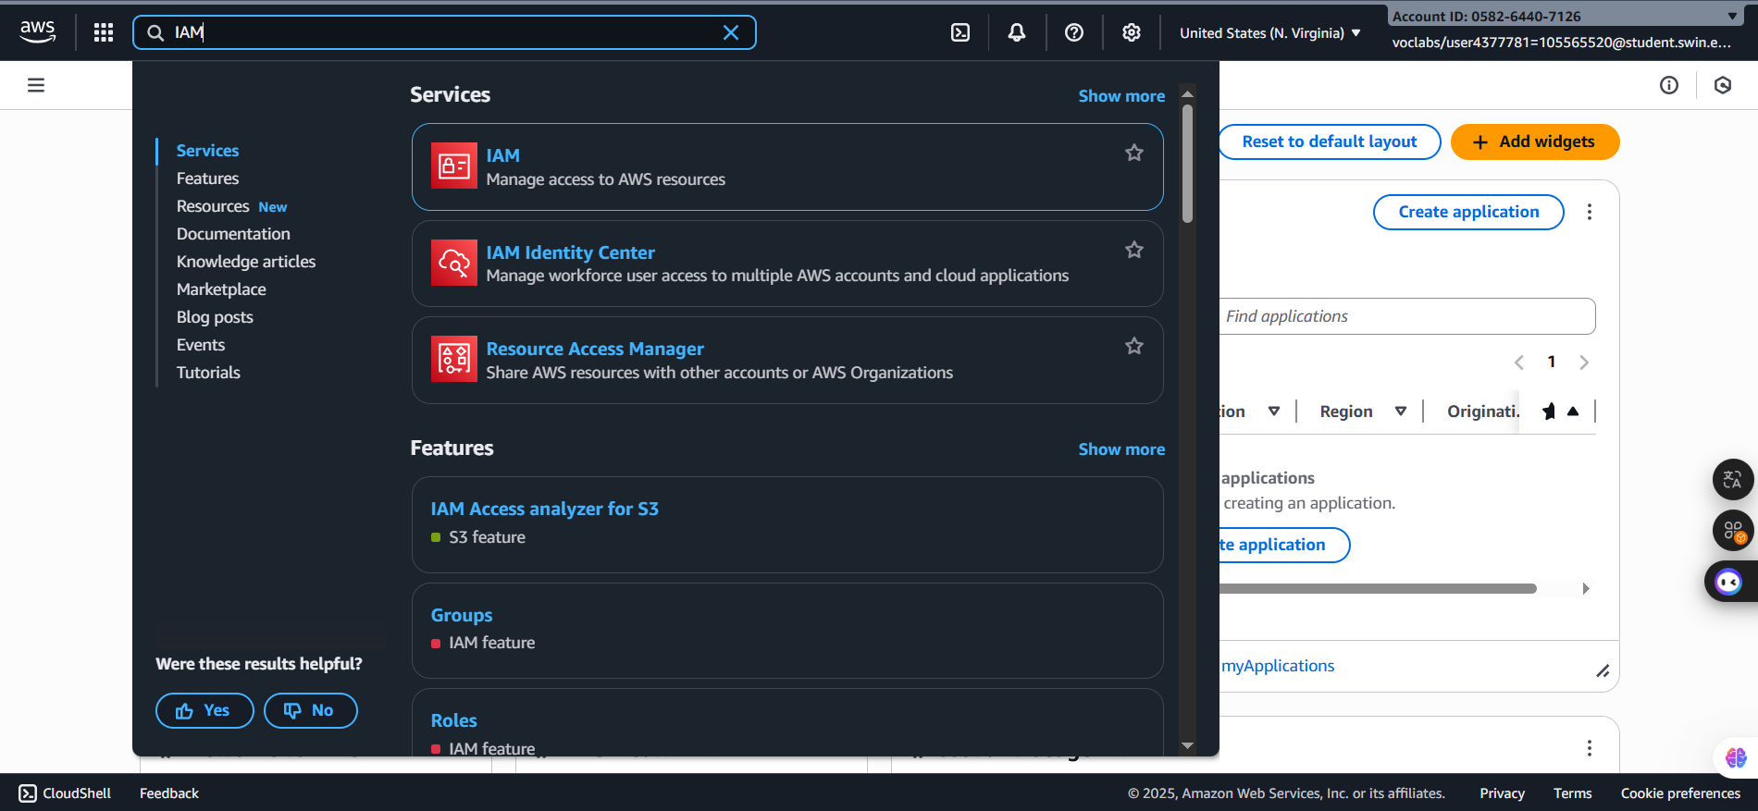Search and select the IAM***

**Step 1.2:** In the IAM Homepage, choose Users in the left navigation which already contains three following created IAM users:

* user-1
* user-2
* 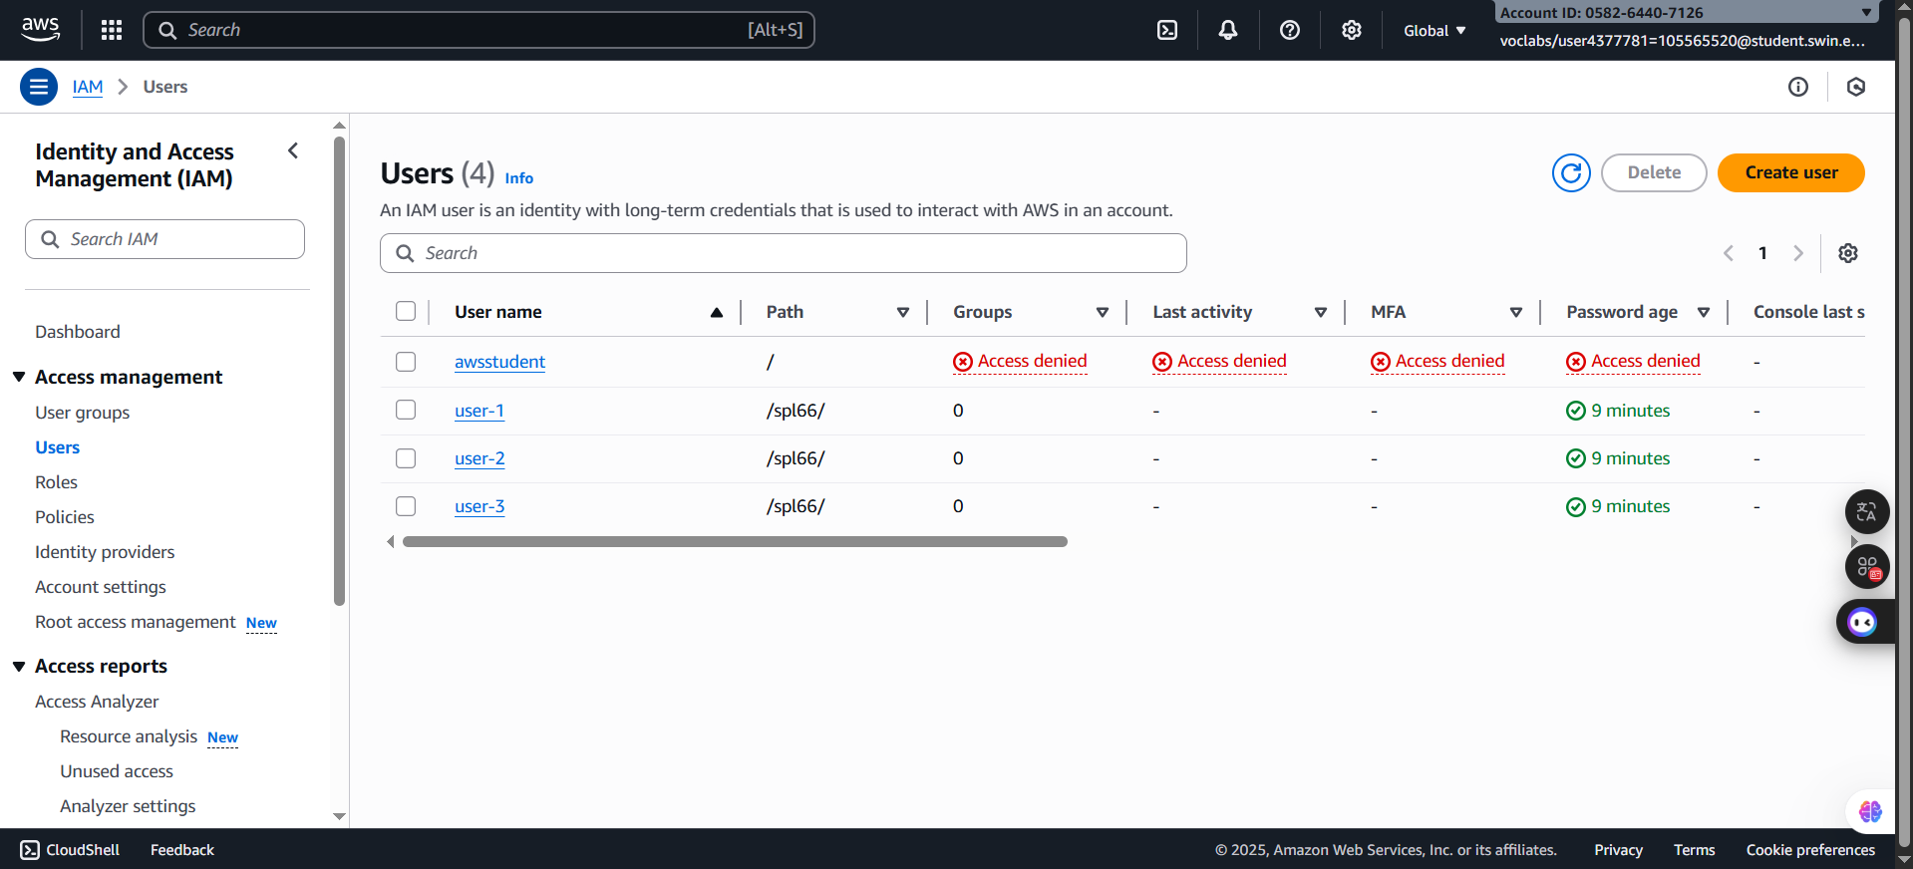user-3

***Figure 3: Users***

**Step 1.4:** Select the user-1 itself to confirm these following instructions:

* **Permissions** tab: for user-1 does not have any permissions
* **Groups** tab: user-1 also is not a member of any groups.
* **Security** **Credentials**: user-1 is assigned a **Console password**.

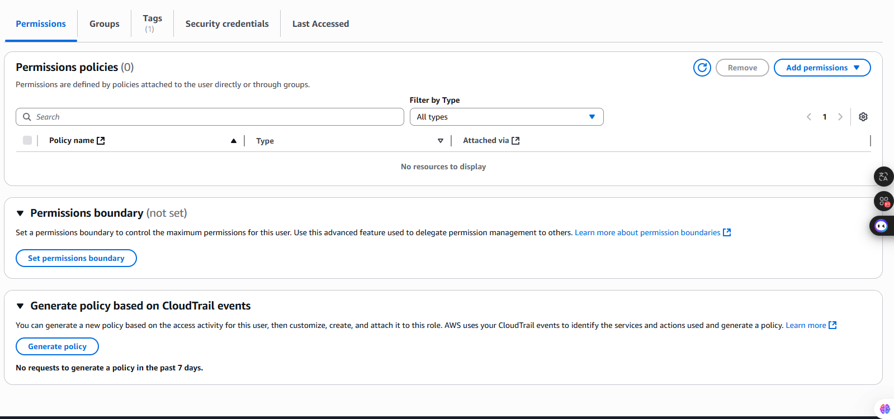

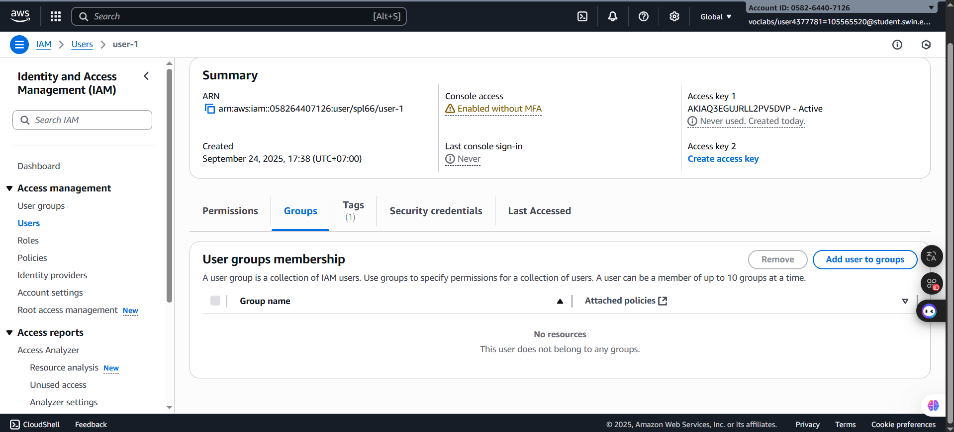 ***Figure 4: Permissions tab***

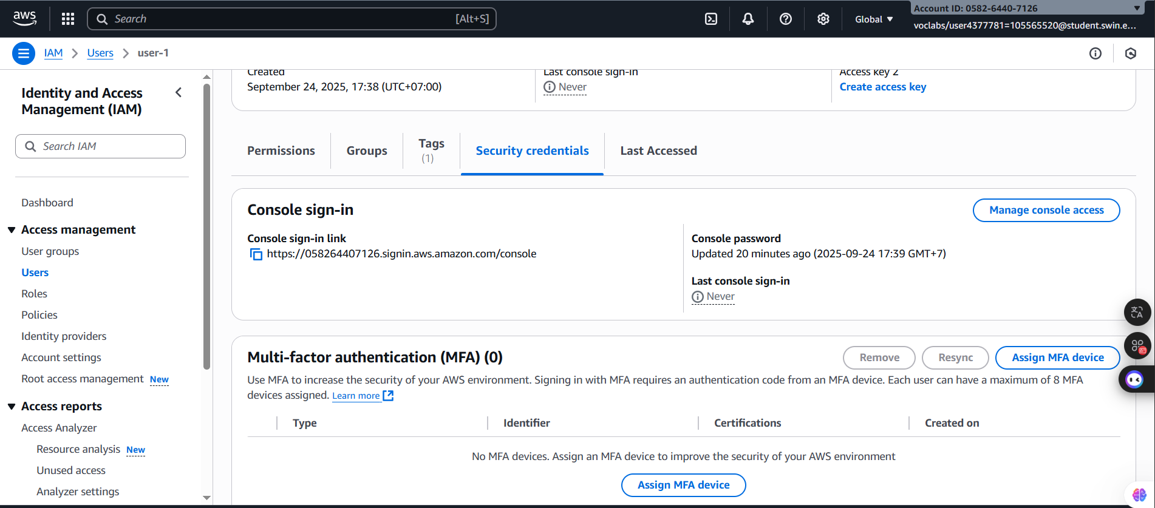***Figure 5: Groups tab***

***Figure 6: Security Credentials tab***

**Step 1.5:** Select the **User groups** in the left navigation to see following already user groups:

* EC2-Admin
* EC2-Support
* 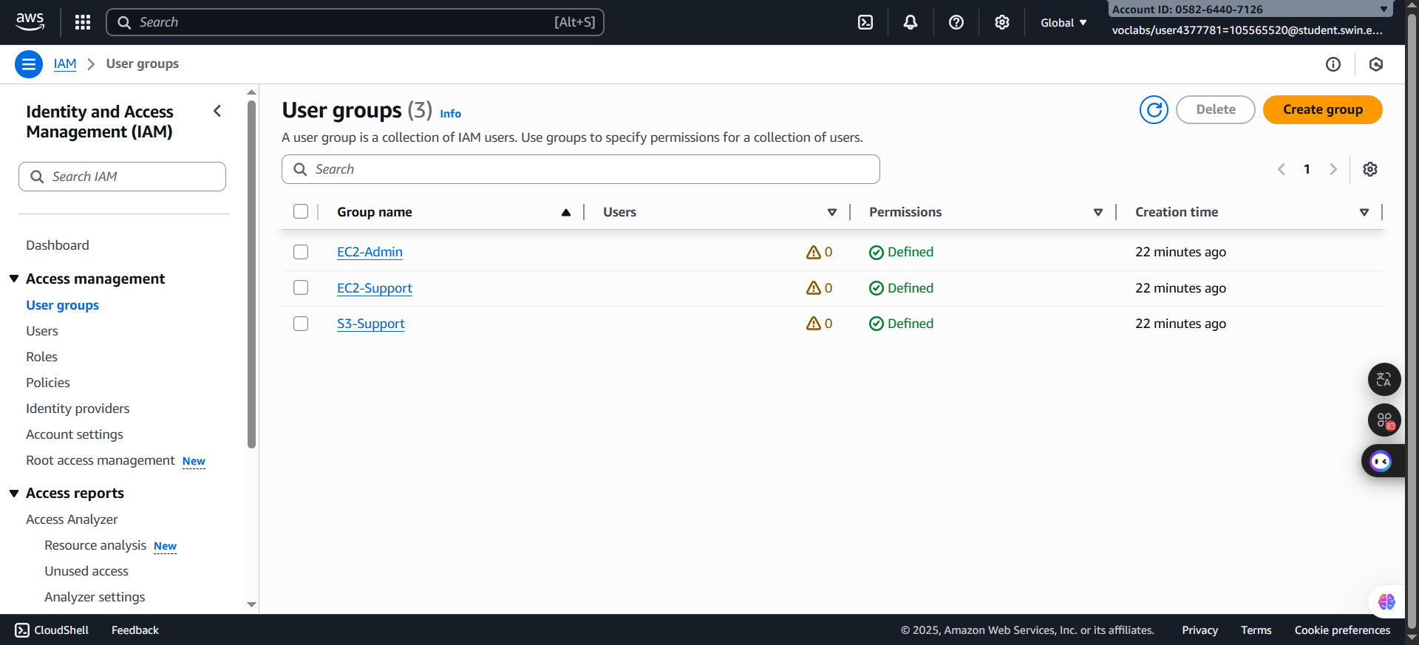S3-Support

***Figure 7: User groups***

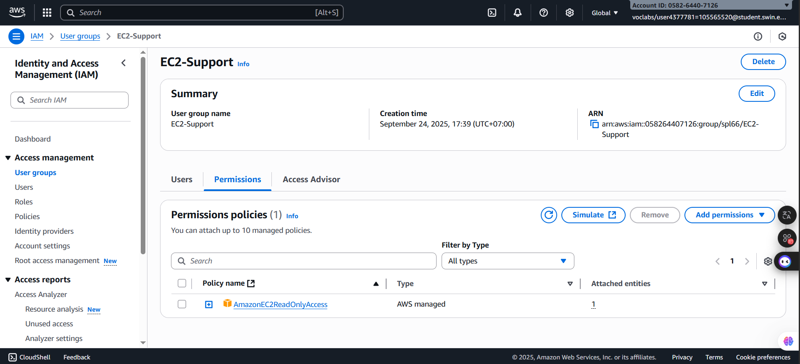**Step 1.6:** Select each group and see **Permissions** tab to see the policy name inside of each group.

***Figure 8: EC2-Support group***

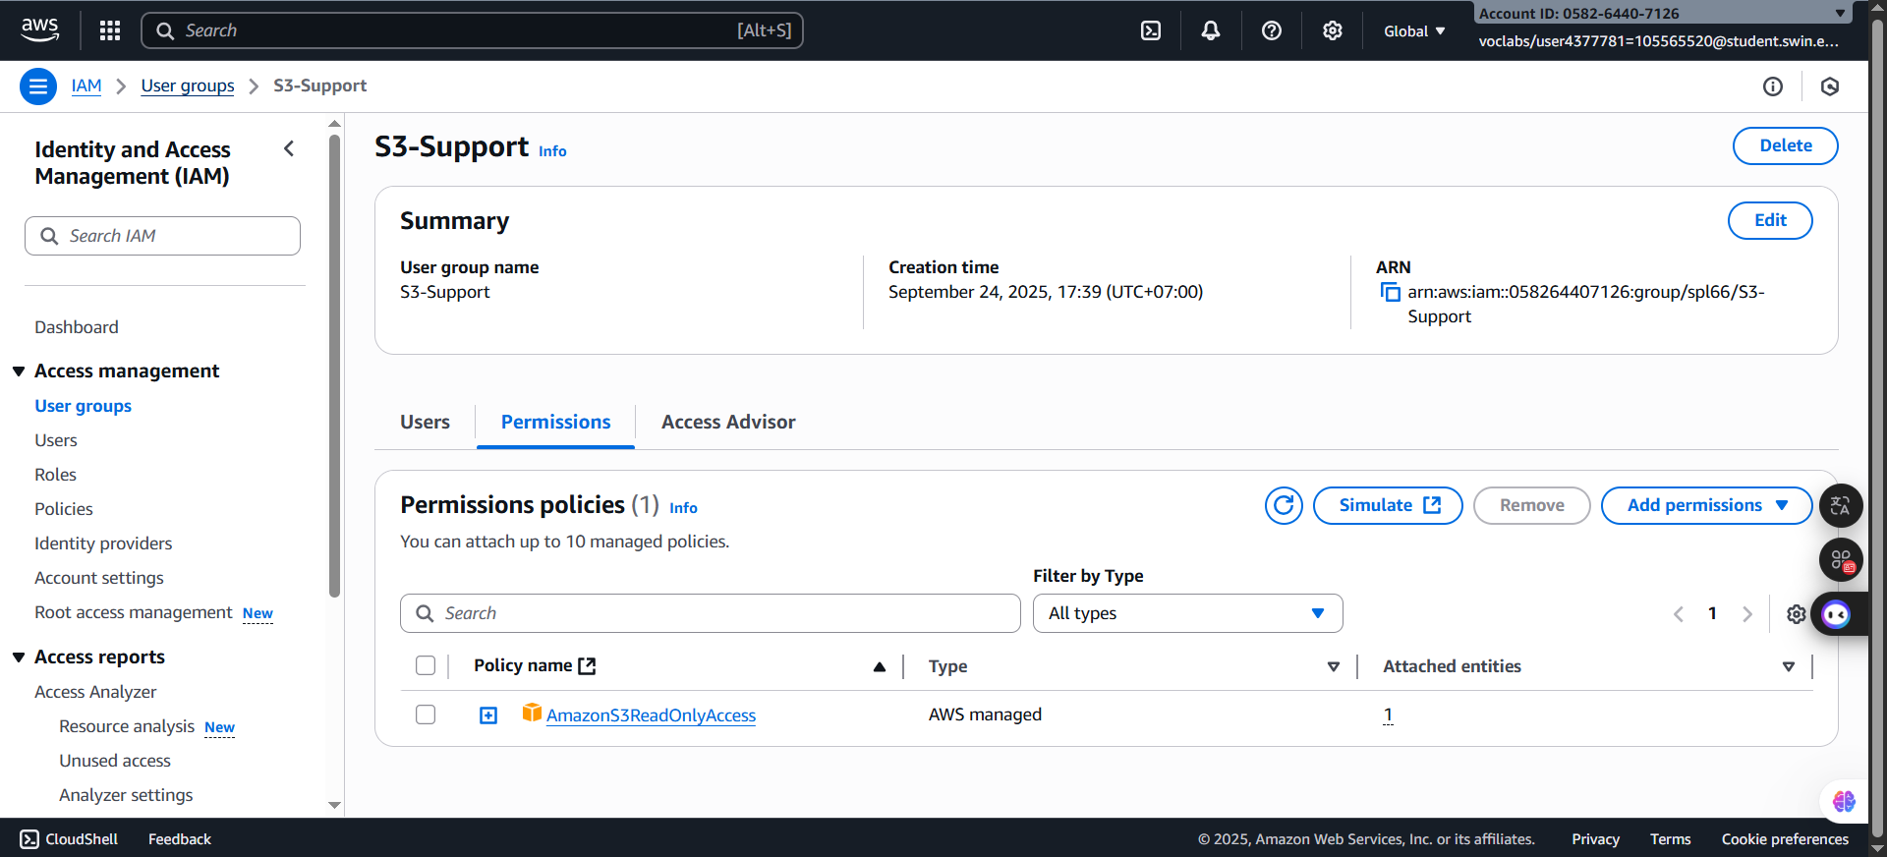***Figure 9: EC2-Admin grou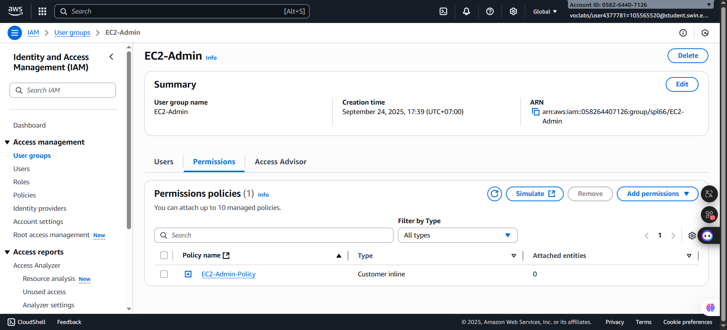p***

***Figure 10: S3-Support group***

***Business Scenario***

For the remainder of this lab, you will work with these Users and Groups to enable permissions supporting the following business scenario:

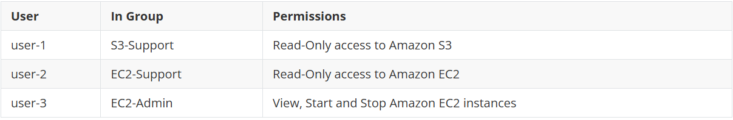Your company is growing its use of Amazon Web Services, and is using many Amazon EC2 instances and a great deal of Amazon S3 storage. You wish to give access to new staff depending upon their job function:

**D. Task 2: Add Users to Groups**

You have recently hired **user-1** into a role where they will provide support for Amazon S3. You will add them to the **S3-Support** group so that they inherit the necessary permissions via the attached *AmazonS3ReadOnlyAccess* policy.



You can ignore any "not authorized" errors that appear during this task. They are caused by your lab account having limited permissions and will not impact your ability to complete the lab.

**Step 2.1: Add user-1 to the S3-Support Group**

- First and foremost, choose the User groups in the left navigation pane and select the **S3-Support** group link. After that, Choose the Users tab. Then, In the **Users** tab, choose **Add users**.

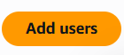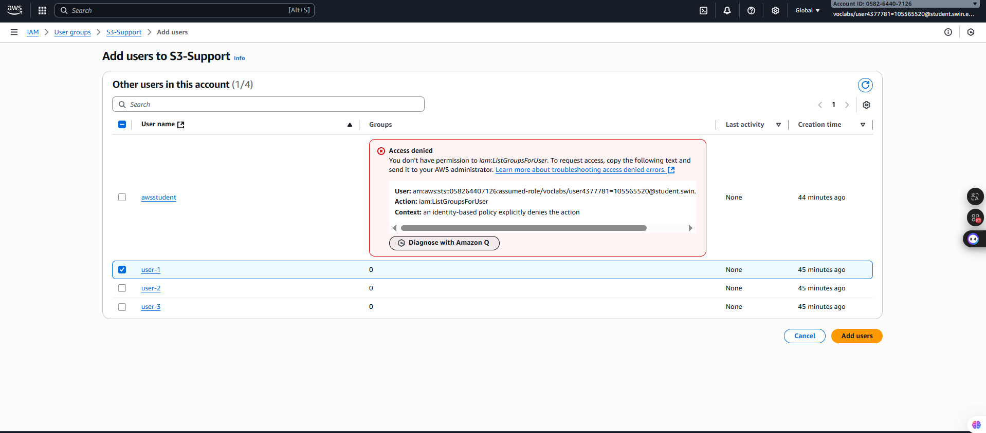- In the **Add users to S3-Support** configuration window, select the **user-1** and choose at the bottom of the screen. ***Figure 11: Add* user-1 *to S3-Support configuration window***

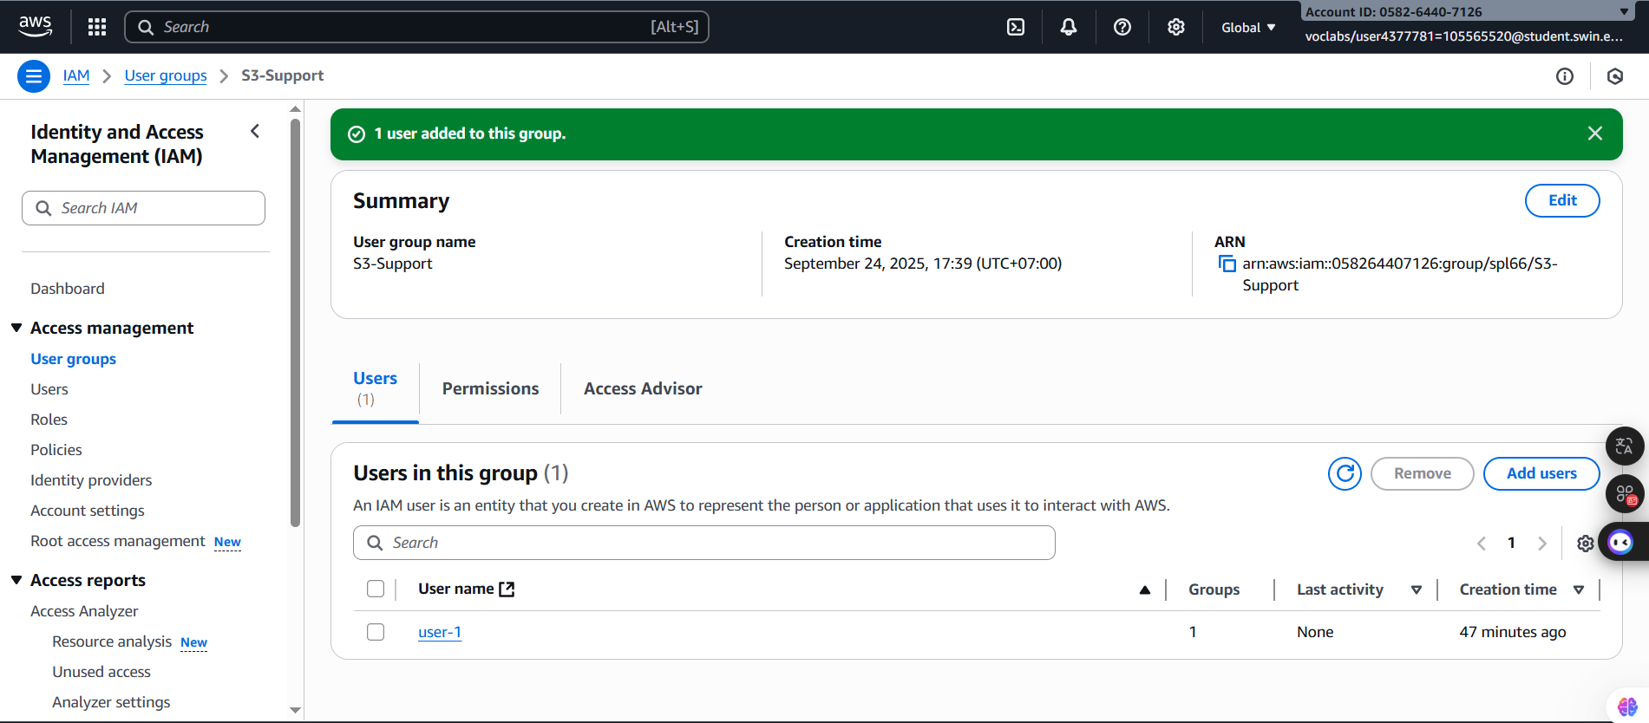***Figure 12: Add user-1 to S3-Support successfully***

**Step 2.2: Add user-2 to the EC2-Support Group**

- Second, choose the User groups in the left navigation pane and select the **EC2-Support** group link. After that, Choose the Users tab. Then, In the **Users** tab, choose **Add users**.

 - In the **Add users to EC2-Support** configuration window, select the **user-1** and choose at the bottom of the screen

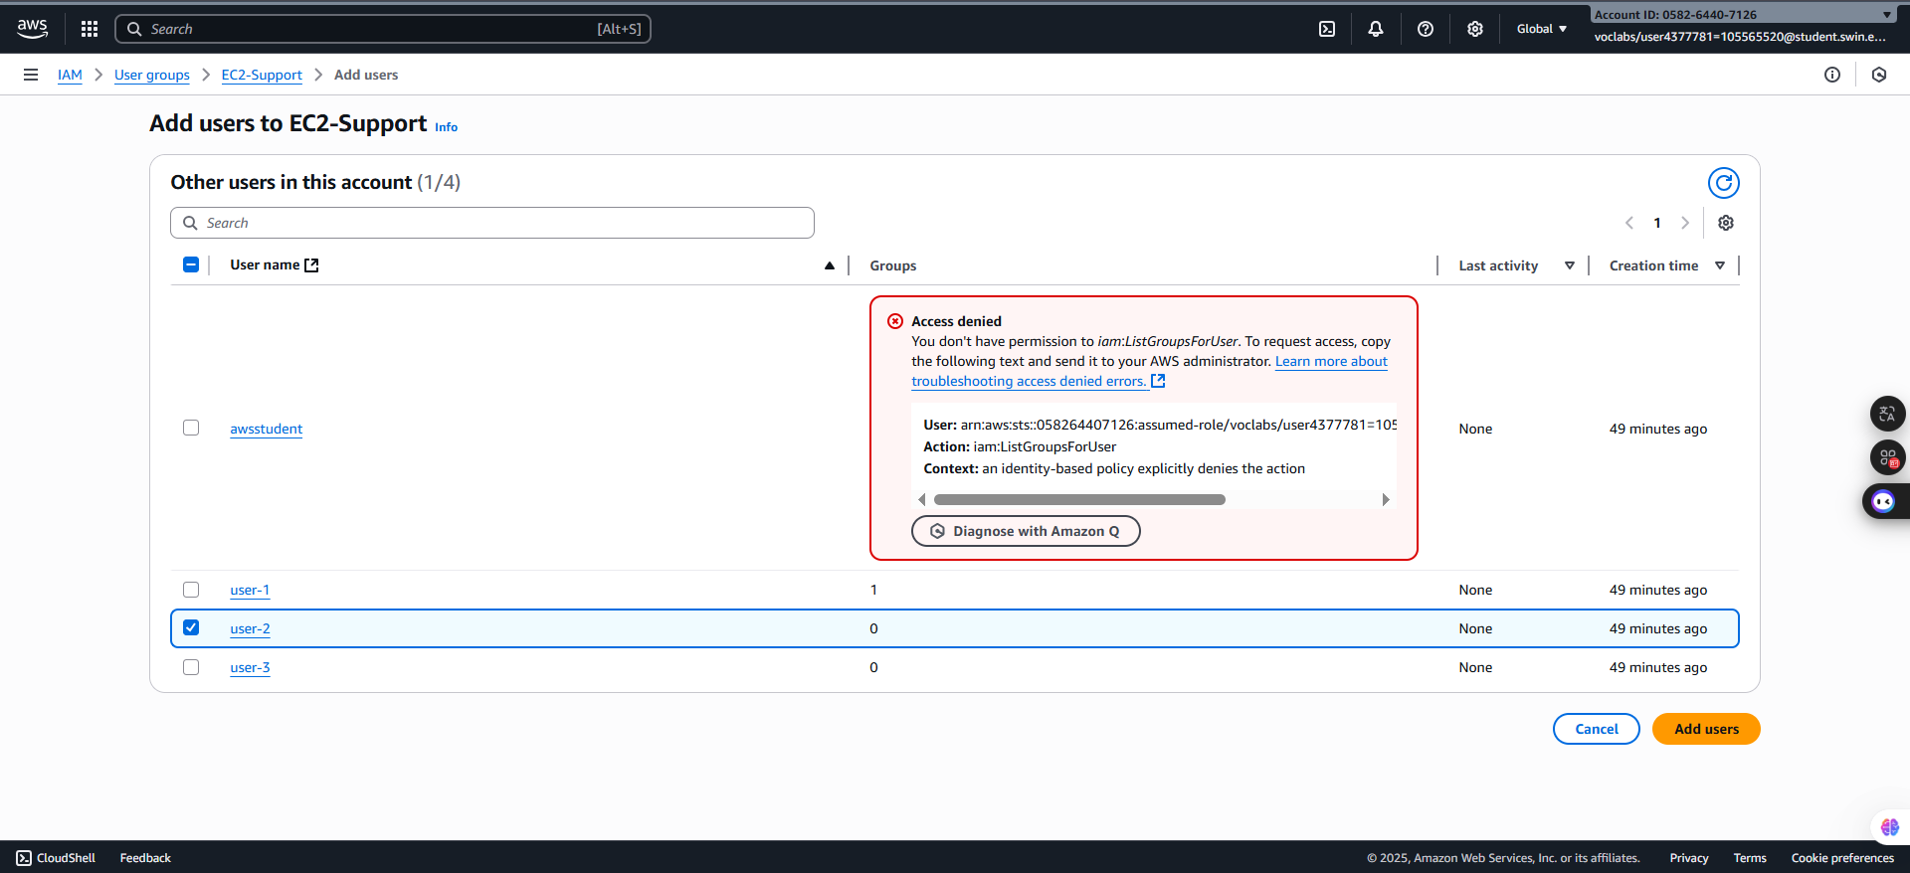

***Figure 13: Add user-2 to EC2-Support******configuration window***

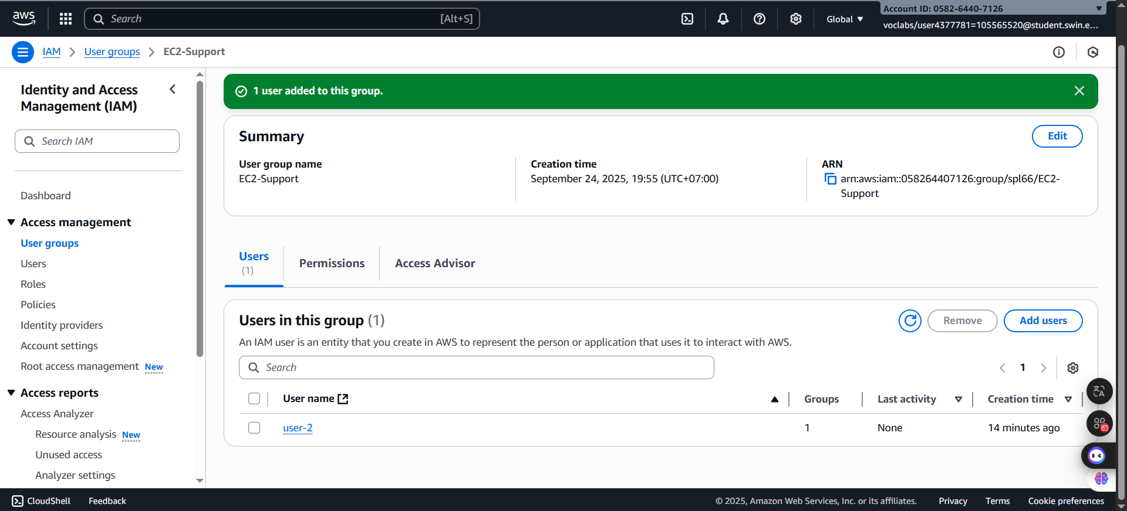

***Figure 14: Add user-2 to EC2-Support******successfully***

**Step 2.3: Add user-3 to the EC2-Admin Group**

- Third. choose the User groups in the left navigation pane and select the **EC2-Admin** group link. After that, Choose the Users tab. Then, In the **Users** tab, choose **Add users**.

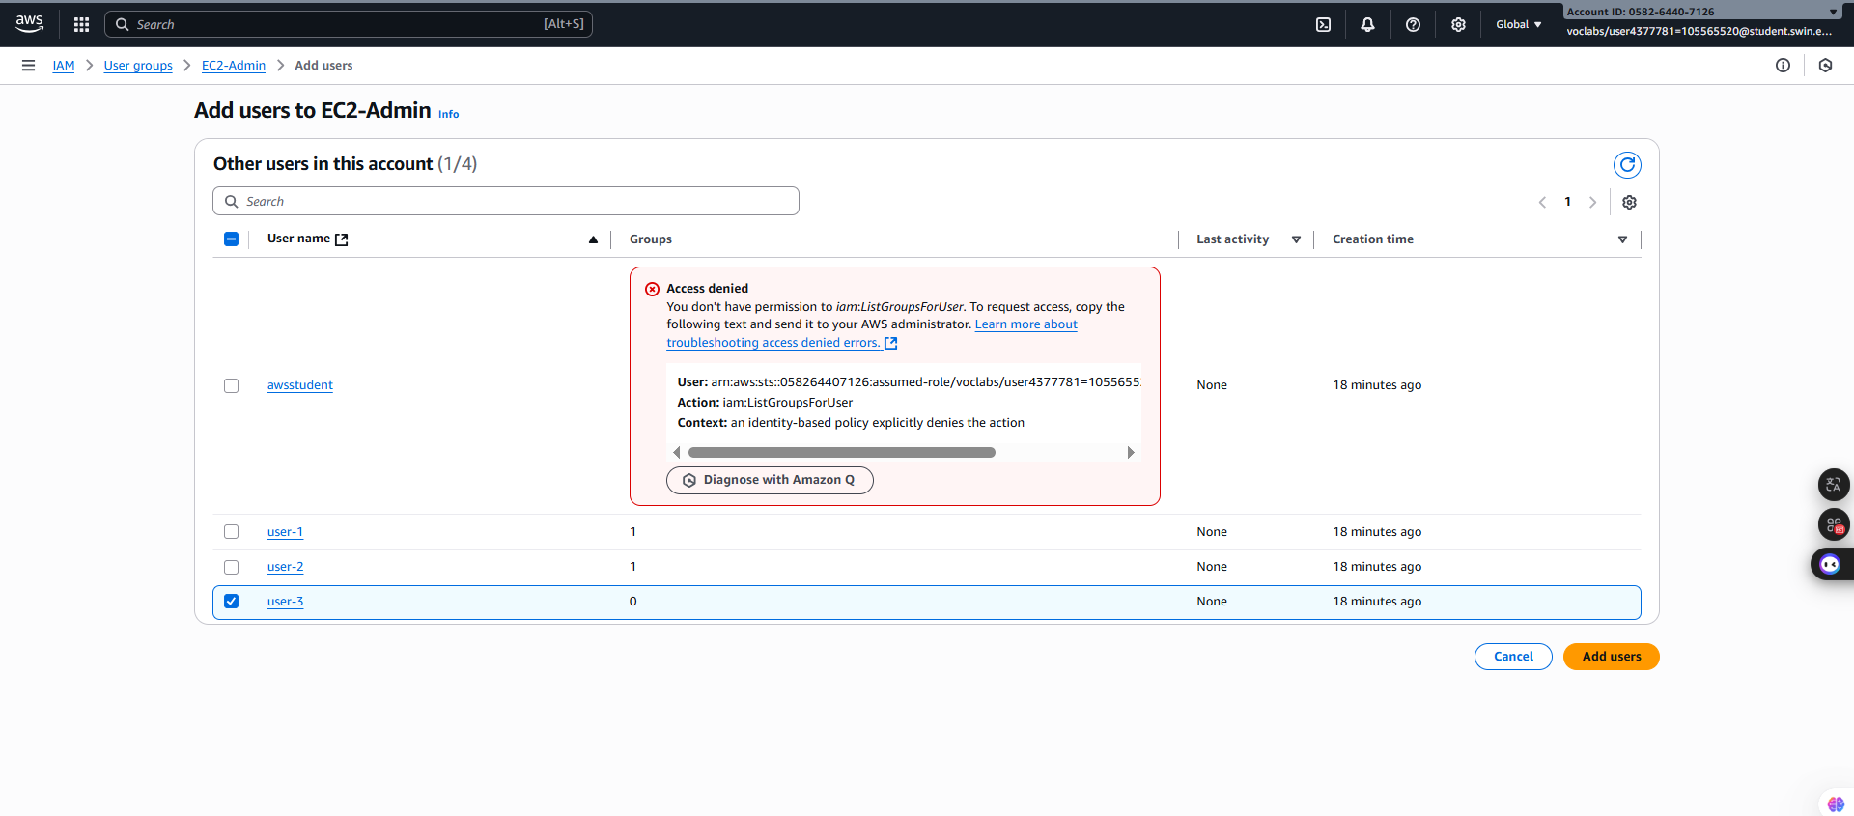 - In the **Add users to EC2-Admin** configuration window, select the **user-3** and choose at the bottom of the screen

***Figure 15: Add user-3 to EC2-Admin configuration window***

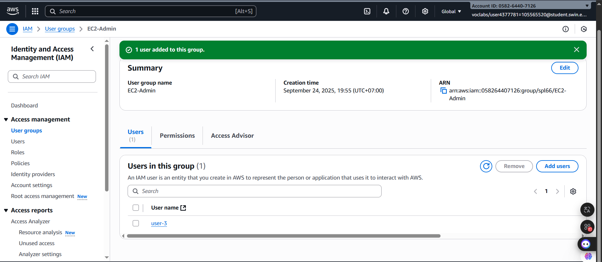

***Figure 16: Add user-3 to EC2-Admin successfully***

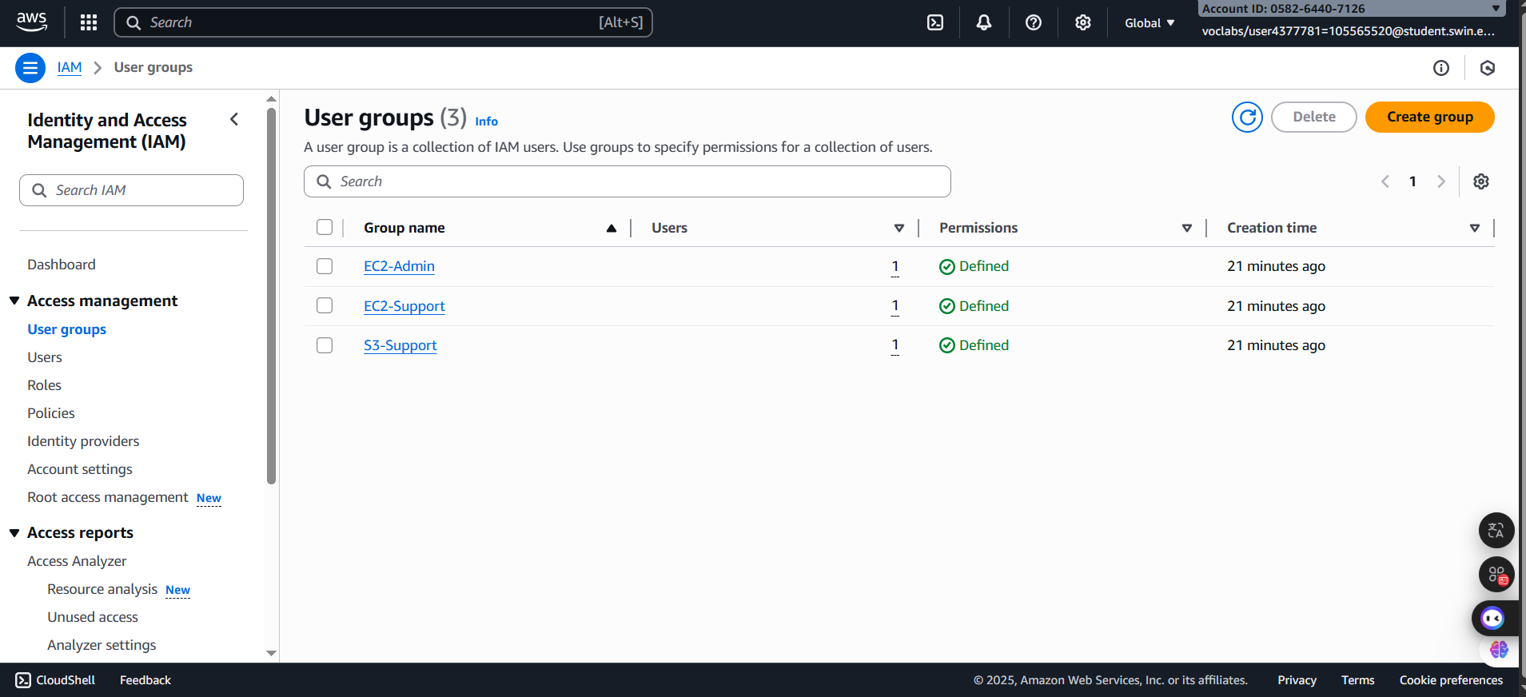**Step 2.4:** Confirm that each **User Group** has 1 **Users**

***Figure 17: User Groups Confirmation***

**E. Task 3: Sign-In and Test Users**

In this task, you will test the permissions of each IAM User.

**Step 3.1:** In the left navigation bar, choose the **Dashboard**

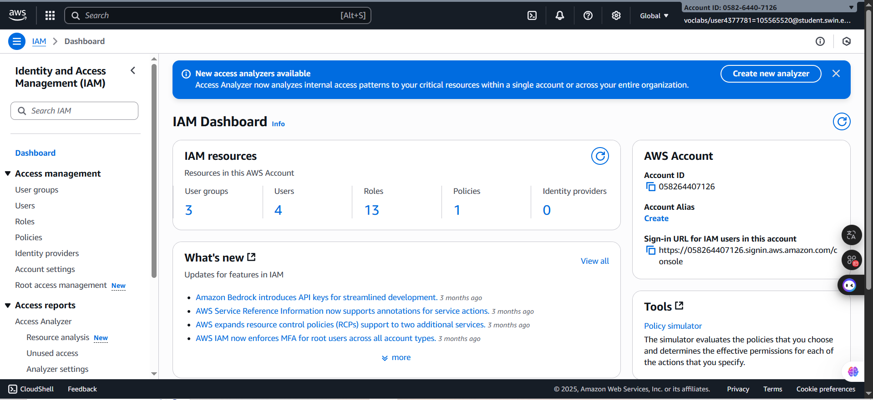

***Figure 18: IAM Dashboard***

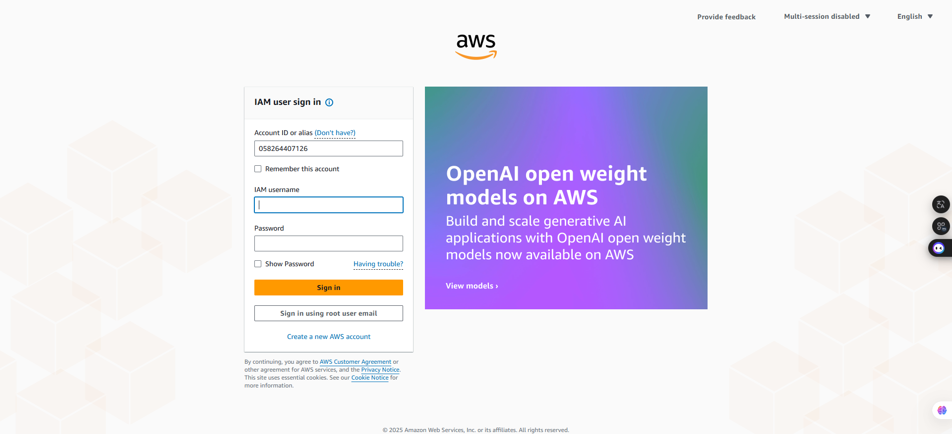 **Step 3.2:** In the AWS Accoun box on the right side, copy the **Sign-in URL for IAM users in this account** and paste it into a new browser tab

***Figure 19: Sign-in AWS Interface***

**Step 3.3:** Sign in the AWS Interface with following requirements:

* **IAM user name:** user-1
* **Password:** Lab-Password1

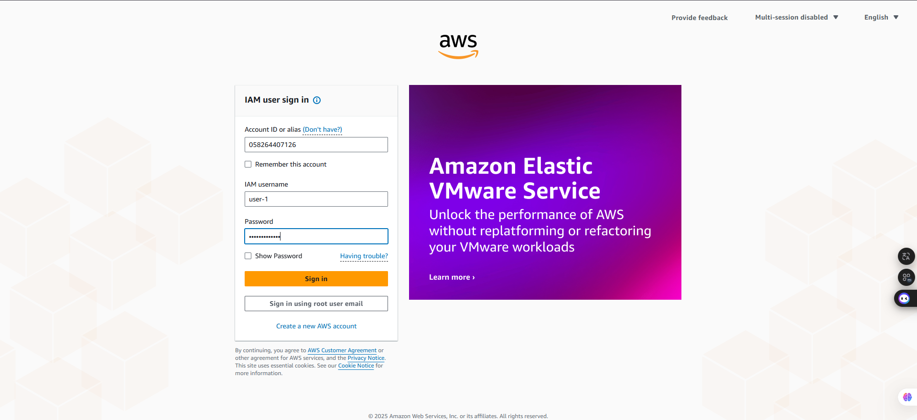

***Figure 20: Sign-in AWS with user-1 account***

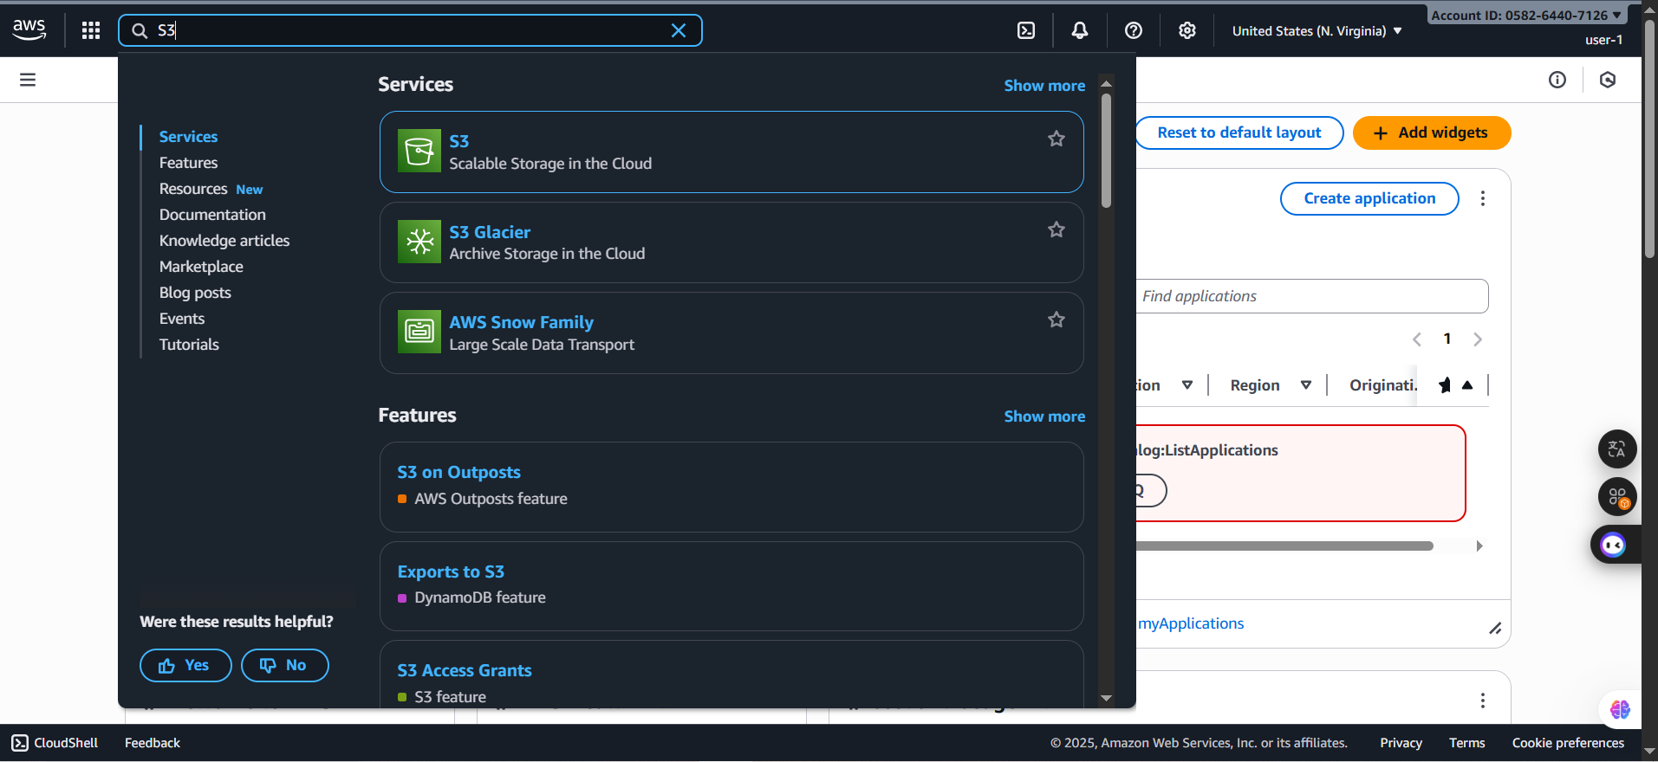 **Step 3.4:** Then, search and choose **Amazon S3**

***Figure 21: Searching Amazon S3***

**Step 3.4:** Next, choose the sample bucket in the **Amazon S3**

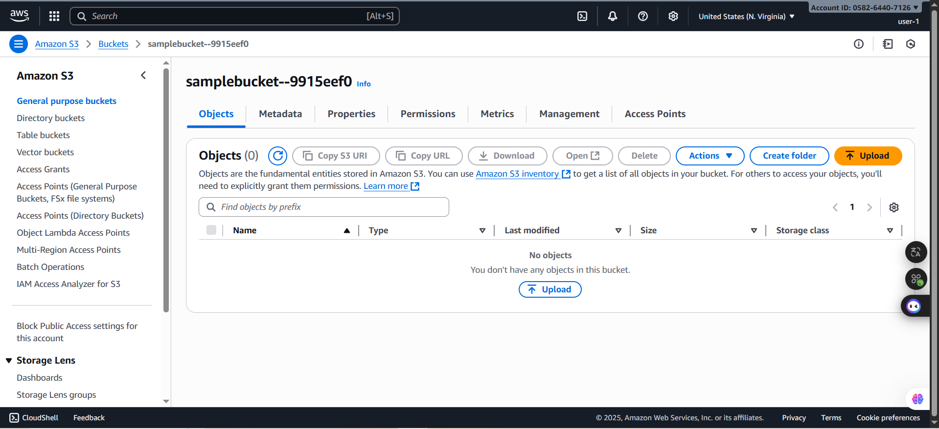

***Figure 22: Choosing the sample bucket***

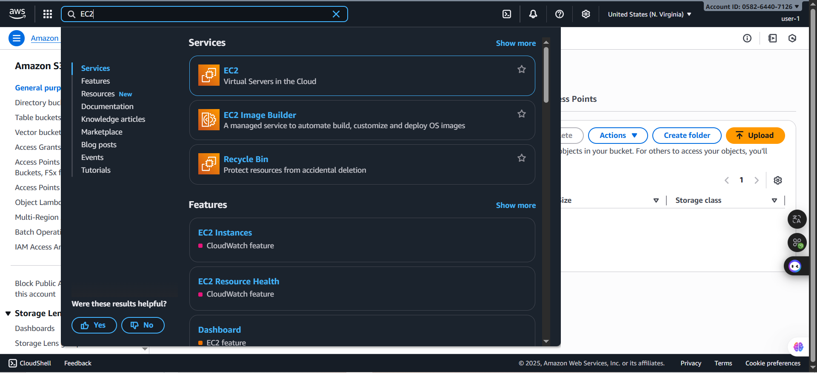**Step 3.5:** In the next step, search the **EC2** and choose **Instances**

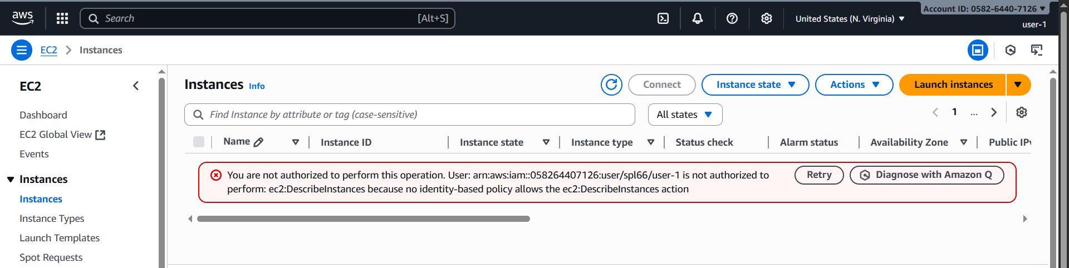***Figure 23: Searching the EC2***

***Figure 24: EC2 homepage***

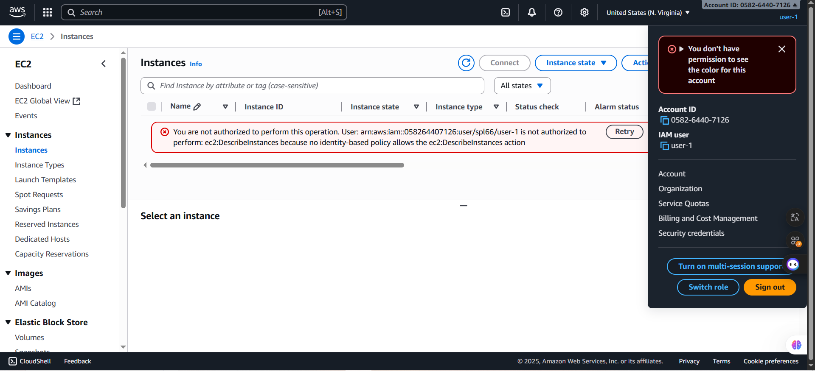**Step 3.6:** Sign out the **user-1** in the AWS Management Console by clicking on the account name which is located in the top right corner of the screen.

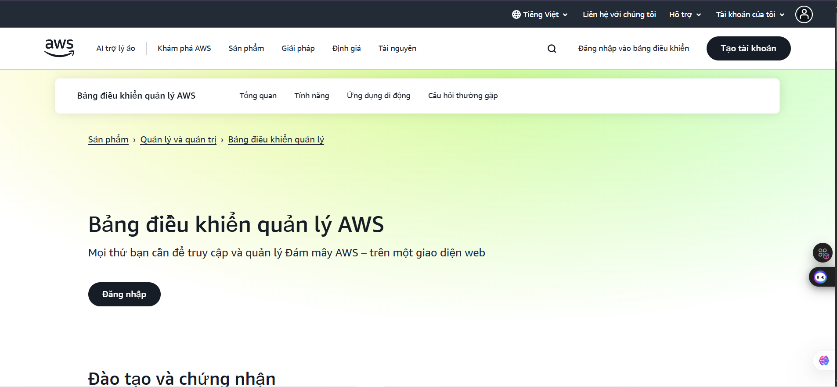***Figure 24: Sign out***

***Figure 25: Sign out successfully interface***

**Step 3.7:** Sign in the AWS Interface again with:

* **IAM user name:** user-2
* **Password:** Lab-Password2

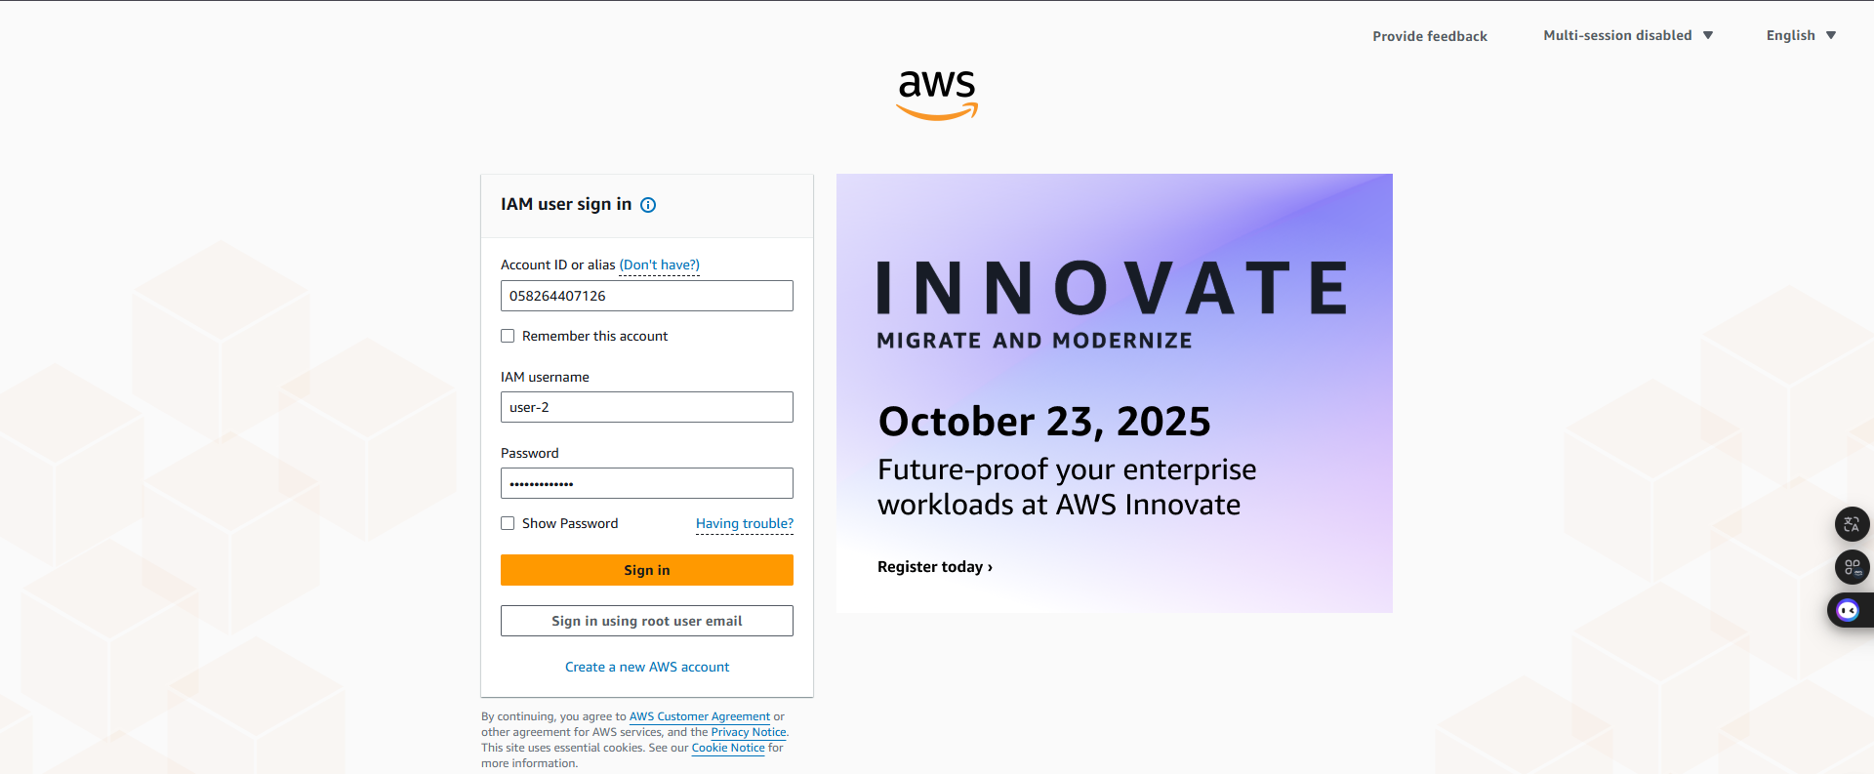

***Figure 26: Sign-in AWS with user-2 account***

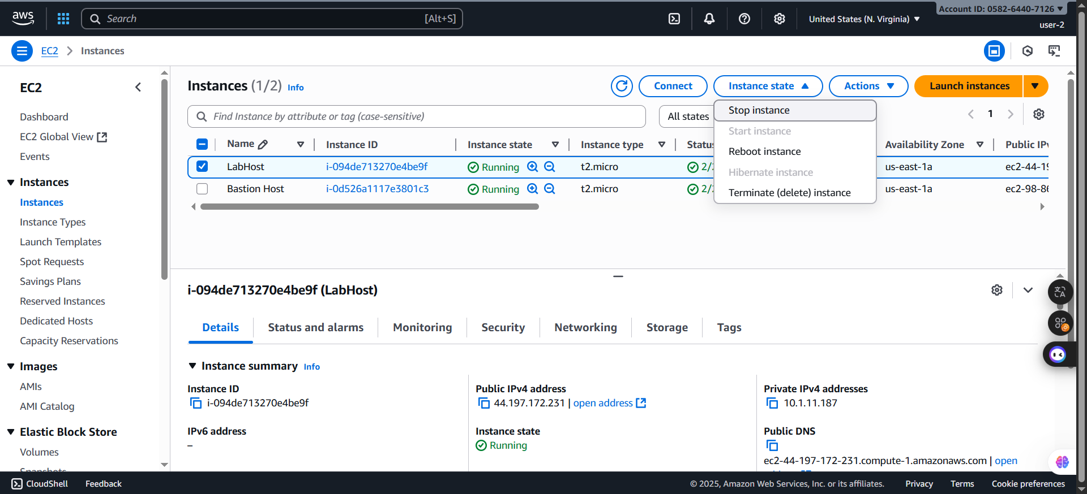**Step 3.8:** After signing in successfully into the AWS with user-2 account, select the **Instances** in the left side panel and select the **LabHost.** In the **Instance state** menu above, select **Stop instance.**

***Figure 27: Select the instance to stop***

**Step 3.9:** In the **Stop Instance** window, select **Stop**.

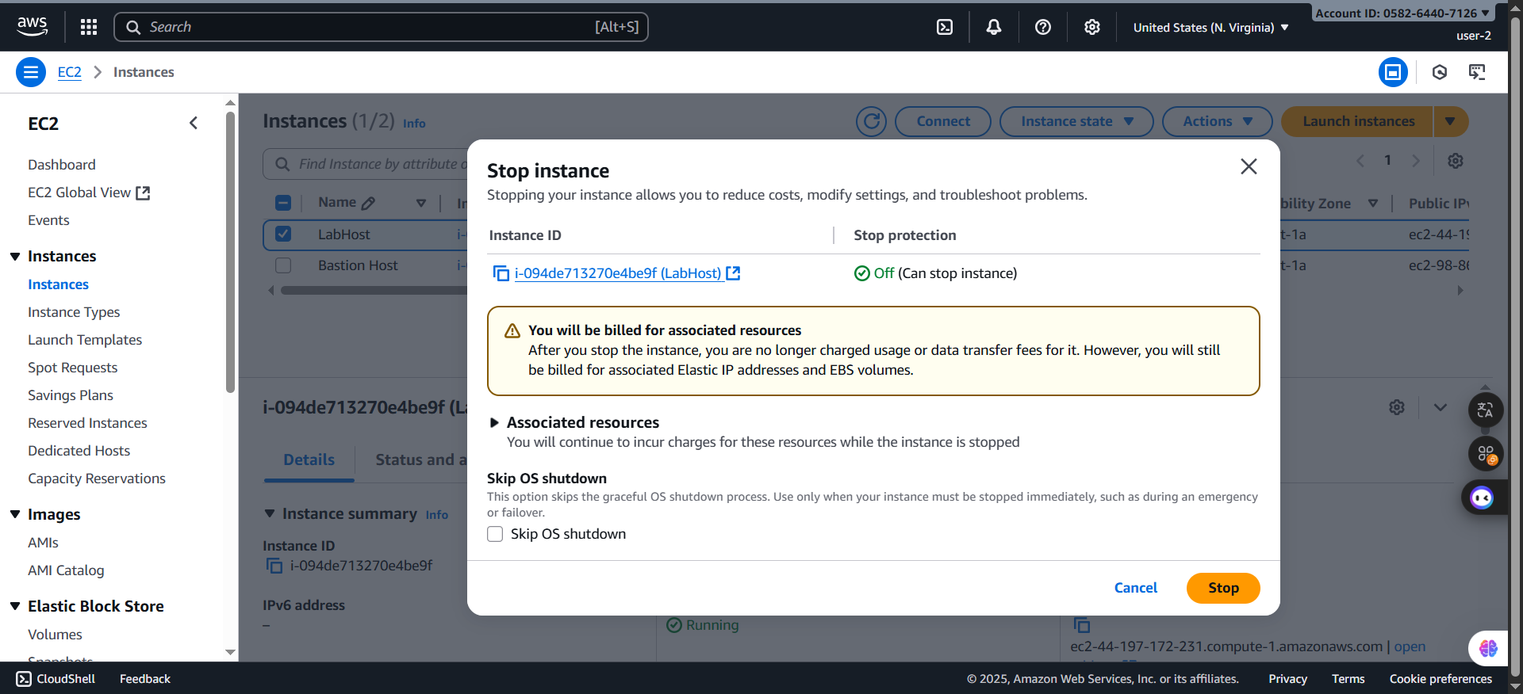***Figure 28: Stop announcement***

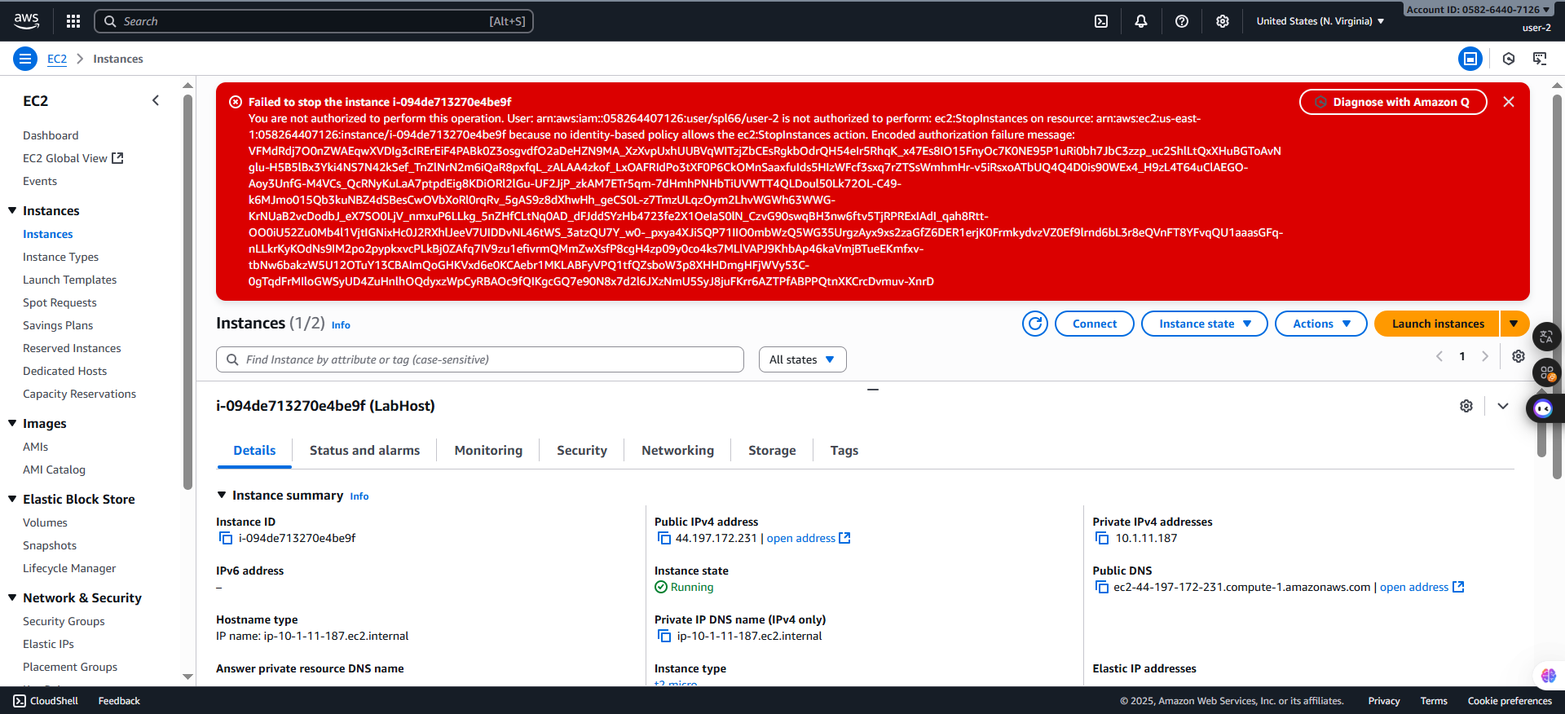

***Figure 29: Failed to stop***

**Step 3.10:** In the searching bar, search **Amazon S3** to see the announce “**You don't have permissions to list buckets**”. After that, similarly to **user-1**, sign out and move to **user-3**

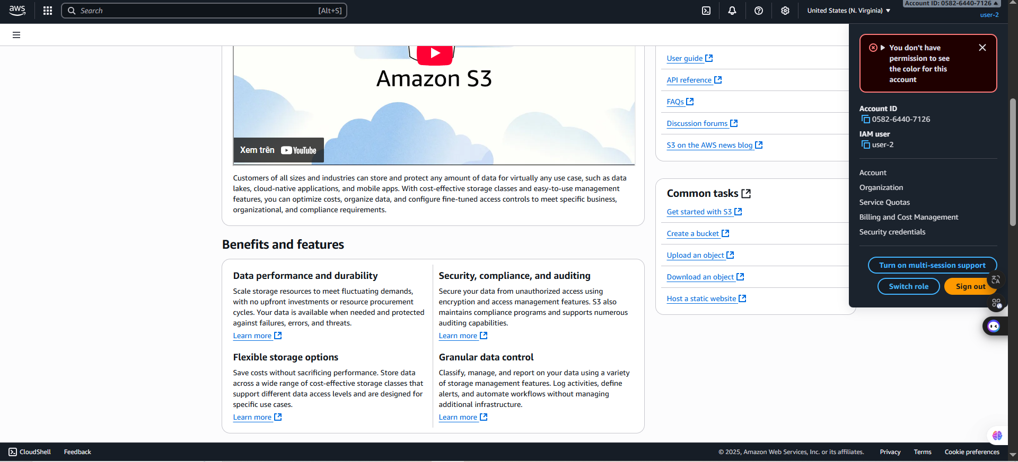

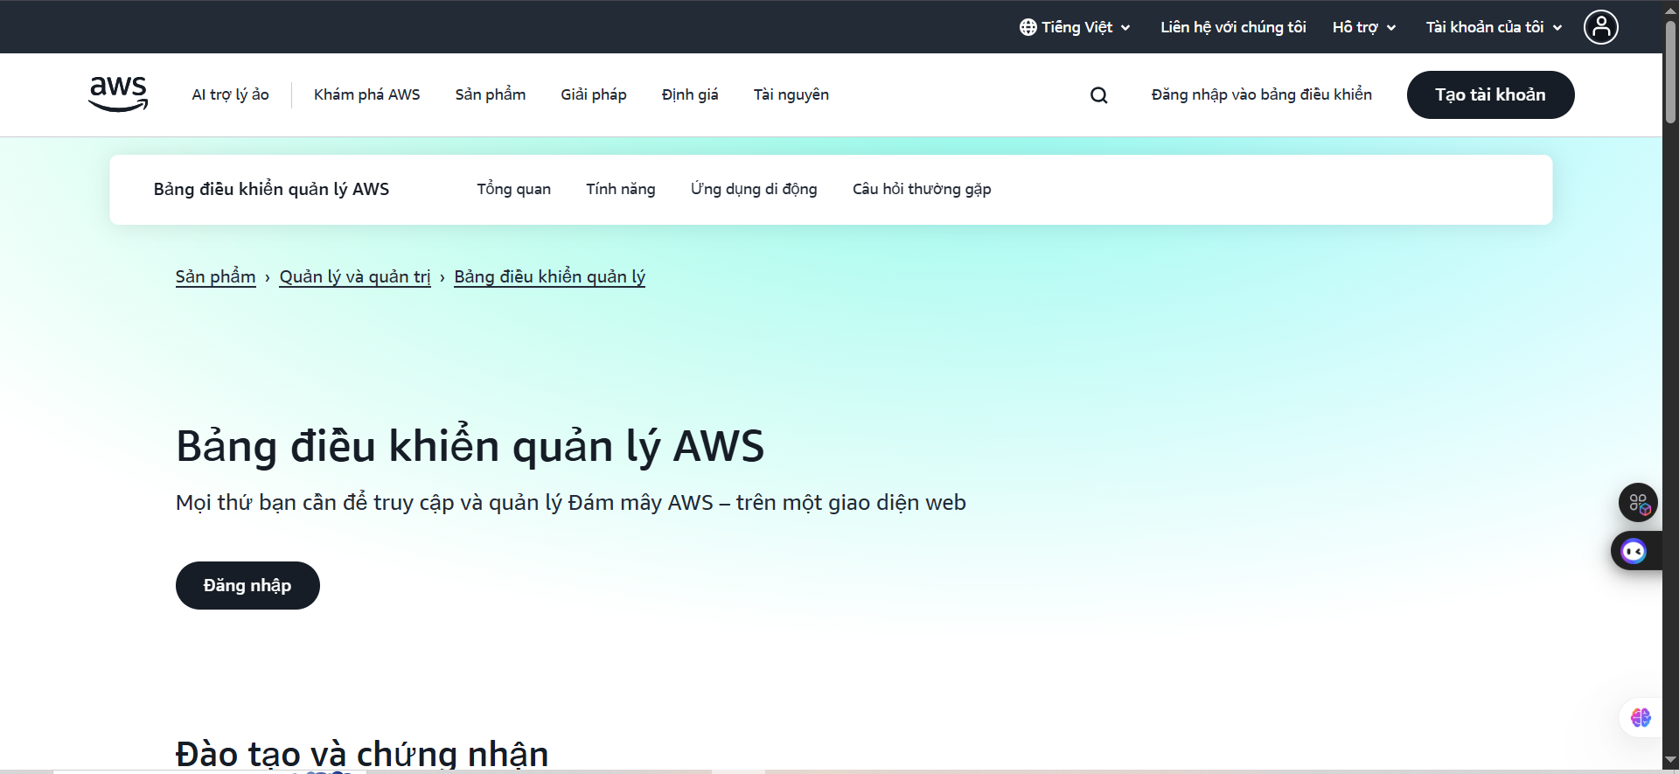***Figure 30: Sign out preparation***

***Figure 31: Sign out successfully***

**Step 3.11:** Paste the **IAM users sign-in link** into a new browser tab and press **Enter.** Then, sign in with:

* **IAM user name**: user-3
* **Password:** Lab-Password3

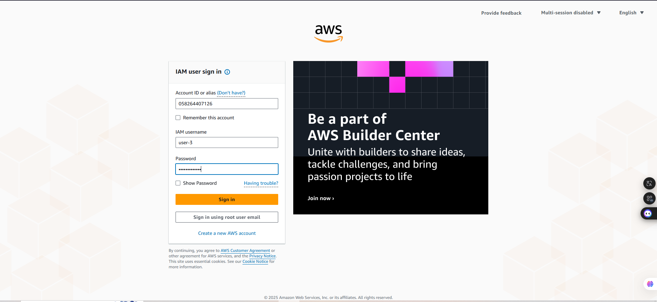

***Figure 32: Sign in with user-3 account***

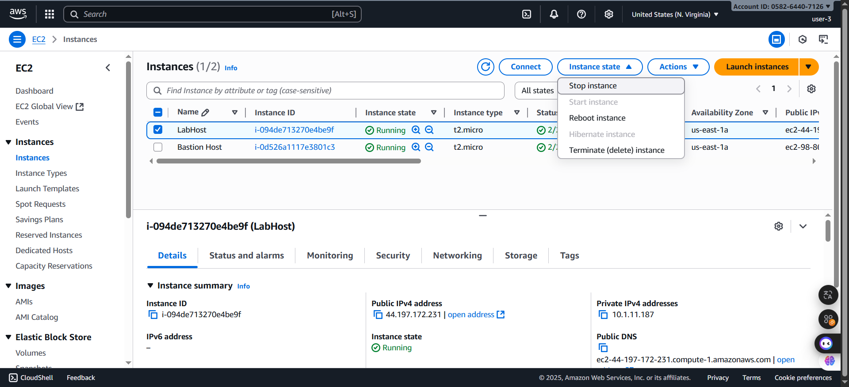**Step 3.12:** When logging successfully, search in the search box **EC2** and select the instance **LabHost**, then n the **Instance state** menu, choose **Stop instance**.

***Figure 33: Stop instance selection***

- As I expected, the instance dispplays the warning before stopping the instance

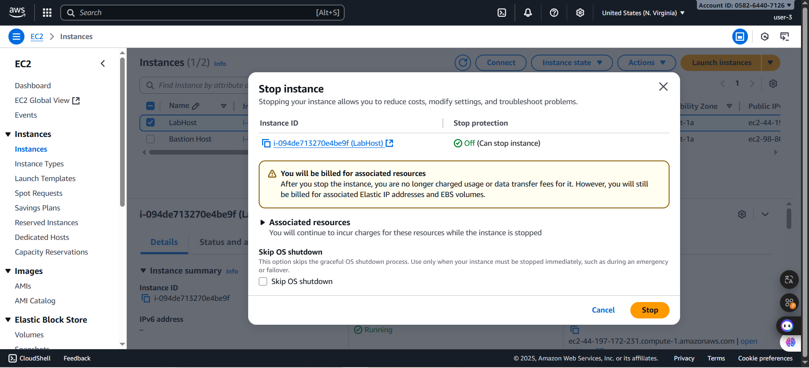

***Figure 34: Stop instance announcement***

- After clicking the **Stop** button and waiting for moment, the instance finally **stopped**

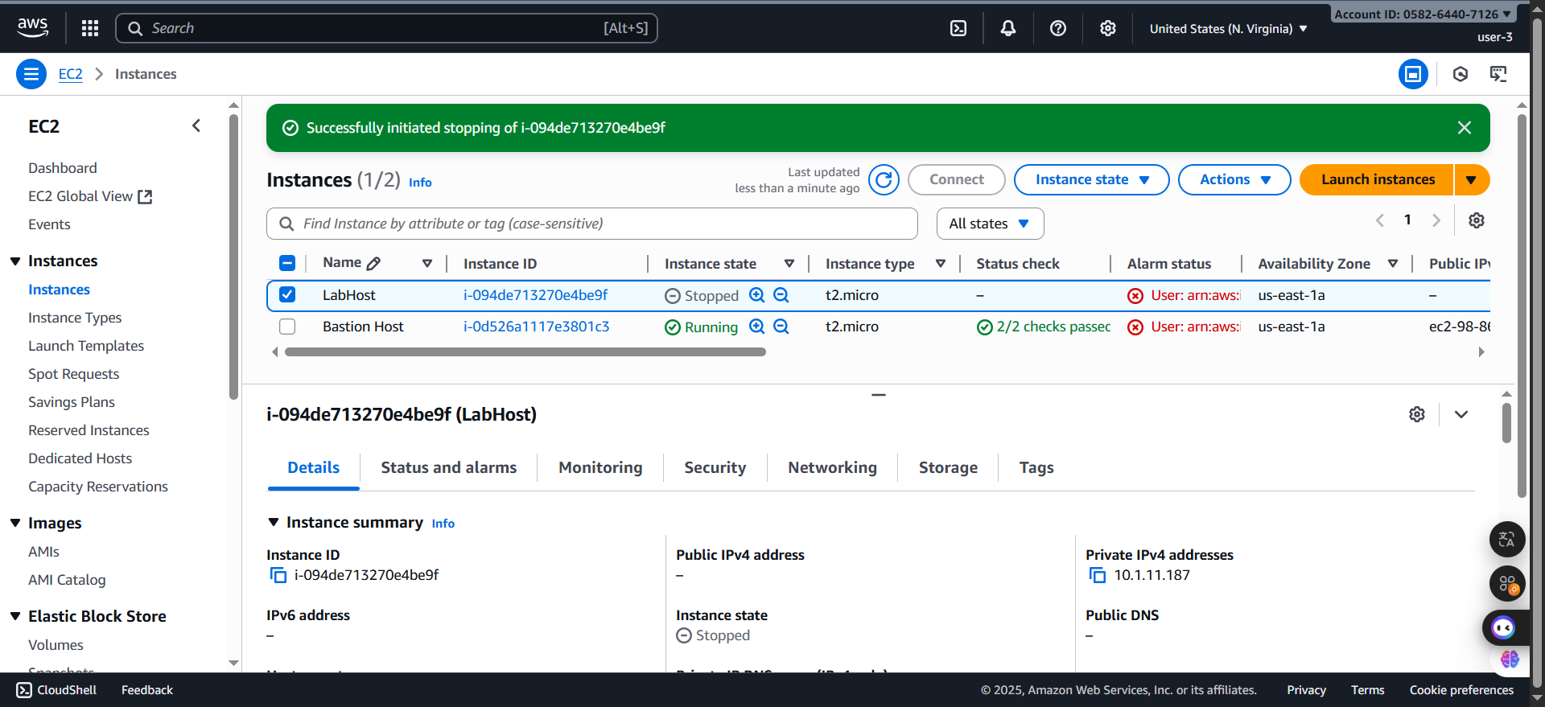

**F. Completed Task**

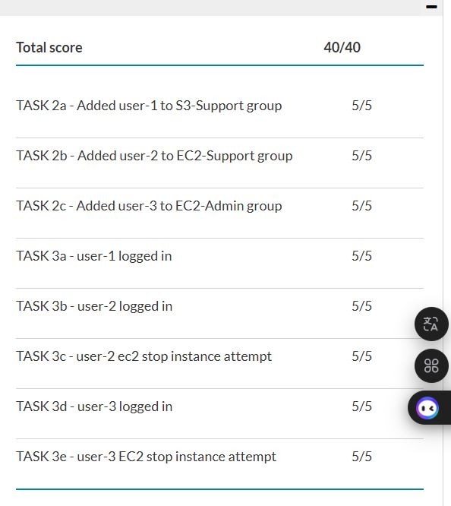

**G. Conclusion**

- In this lab, I learned how to use AWS Identity and Access Management (IAM) to manage users, groups, and permissions. I explored the existing IAM users and groups, examined the policies attached to them, and practiced adding users to the appropriate groups based on their roles. I also tested the permissions by signing in as different users and observing how their access was restricted or allowed depending on their assigned policies.

- Through this experience, I understood the importance of IAM in controlling access to AWS resources and ensuring security by applying the principle of least privilege. I realized how user and group configurations directly impact what actions can be performed in the AWS environment. Overall, this lab helped me build confidence in managing identities and permissions securely in AWS.